NAME: SAGARSUMAN P MANJHI SUBJECT: PYTHON PROGRAMMING LAB | PRACTICAL: 06 | BATCH : 04  SYBVOC :SEM-III (DS)
Experiment Based on Functions and Modules

AIM : To study and implement user-defined functions, function arguments, return values, recursion, and built-in modules by developing a Restaurant Billing System that calculates the bill, applies GST and discount using functions, and generates a unique bill number using the random module.
LEARNING OBJECTIVE :
  - To understand user-defined functions in Python.
  - To learn function arguments and return values.
  - To perform calculations using functions.
  - To understand the use of built-in modules.
  - To generate a random bill number using the random module.
  - To develop a restaurant billing system using Python.
TOOLS :

Sr. No. | Name Of Resources | Specification | Quantity | Remarks
1. | Hardware | Computer (i5-i7) Ram (Min 16GB) | 1 | For All Practical
2. | Software | Python / IDLE / VS Code | 1 | For All Practical
THEORY :
1. Functions: A function is a reusable block of code that performs a specific task. It is defined using the def keyword.
Example:
def greet(): print("Welcome to Restaurant")
2. Function Arguments: Arguments are values passed to a function when it is called. They allow a function to work with different inputs.
Example:
def calculate_total(price, quantity): return price * quantity
3. Return Statement: The return statement sends a result back to the calling function.
Example:
def square(n): return n * n
4. Recursion: Recursion is a technique in which a function calls itself to solve a problem. A base condition is required to stop recursive calls.
Example:
def factorial(n): if n <= 1: return 1 return n * factorial(n - 1)
5. Modules: A module is a Python file containing functions and other code that can be reused in a program. Python provides built-in modules such as random and math.
Example:
import randomprint(random.randint(1000, 9999))
Source Code:
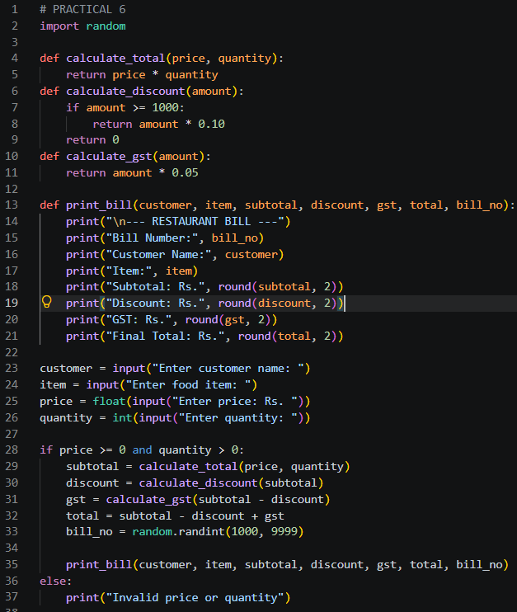
Output:
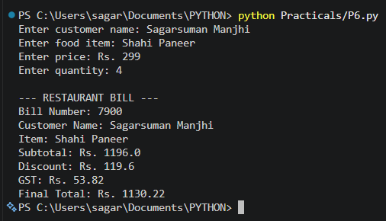
Result and Discussion:
The Restaurant Billing System was implemented successfully using Python functions and the random module.The program accepts customer details, calculates the subtotal, applies a 10% discount when the subtotal is ₹1,000 or more, calculates 5% GST on the discounted amount, generates a random four-digit bill number, and displays the final bill.
Learning Outcomes:
- Learned to define and call user-defined functions.
- Understood function arguments and return values.
- Used the random module to generate a bill number.
- Practised input validation and arithmetic operations.
- Developed a modular Python application for restaurant billing.
Course Outcomes:
- Understand Python programming fundamentals and functions.
- Apply function arguments and return values to solve problems.
- Use built-in modules to perform specific operations.
- Develop a modular Python application for a real-world problem.
CONCLUSION :
The Restaurant Billing System was developed successfully using Python functions and the built-in random module. The program calculates the subtotal, applies the eligible discount, calculates GST, generates a random bill number, and displays the final amount. This practical demonstrates how modular programming can be used to solve a real-world billing problem.

VIVA QUESTIONS :
Q1. What is a function in Python?
A function is a reusable block of code designed to perform a specific task.
Q2. Which keyword is used to define a function?
The def keyword is used to define a function.
Q3. What are function arguments?
Arguments are values passed to a function when it is called.
Q4. What is the purpose of the return statement?
It returns a value from a function to the calling code.
Q5. What is a Python module?
A module is a file containing Python code, such as functions and variables, that can be imported and reused.

FOR FACULTY USE ONLY :
Correction Parameters | Formative Assessment [40%] | Timely completion of practical [40%] | Attendance/ Learning Attitude [20%]
Marks Obtained

